Queenswood Primary School

# **Geography Policy and Planning document**

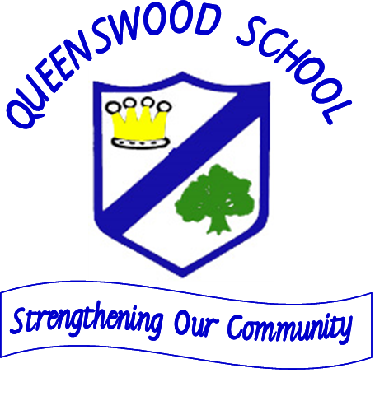**October 2020**

**Introduction:**

* Geography is a statutory subject throughout the whole school
* The requirements for KS1 sand KS2 as set out in the [Programmes of Study](https://www.gov.uk/government/publications/national-curriculum-in-england-geography-programmes-of-study) (PoS), are concise and set out the core knowledge that students should acquire. The PoS do not specify approaches to teaching, nor explain how to put the content into a teaching and learning sequence . The school has produced a progression document for the Geography curriculum to show the sequence of knowledge pupils should acquire as they progress through school. .

### In our curriculum there is an emphasis on locational and place knowledge, human and physical processes and Geographical skills , such as using grid references.

**According to the definitions provided by the Royal Geographic Society, geography informs us about:**

* The places and communities in which we live and work
* Our natural environments and the pressures they face
* The interconnectedness of the world and our communities within it
* How and why the world is changing, both globally and locally
* How our individual and societal actions contribute to those changes
* The choices that exist in managing our world for the future
* The importance of location in business and decision-making

*Royal*

*Geographical Society, 2020*

**The Intent of our Geography Curriculum**

* Pupils will understand and remember the dynamics of cultures, societies and economies through human Geography
* Through physical geography they will know understand the dynamics of landscapes and the environment.
* Pupils will learn the concept of place and relative location - recognising the great differences in landscapes and environments across the world, and exploring the links between them. They will learn the causes of differences and inequalities between places and social groups
* To helps us all to be more socially and environmentally sensitive, better informed, and more responsible as citizens.

**LINKS WITH SMSC**-Geography provide us with a way of developing SMSC through teaching about the global dimension. This subject enables us to make connections between issues such as global citizenship, diversity, human rights and sustainable development.

### **Planning**

When planning Geography think in terms of

* Locational knowledge
* Place knowledge
* Knowledge of human & physical geography
* Knowledge of Geographical skills and fieldwork to help children understand about place.

Geography will be taught at Queenswood through the use of the school’s medium-term plans ( See attached) based on the 2014 National Curriculum and closely following the School’s Geography progression grids to ensure that skills and knowledge are built on and developed year on year.,

It is important to revisit and practice so some knowledge and learning will be revisited in a different context to ensure it is embedded in a child’s long term memory.

The school’s planning document informs teacher planning and contains a sequence of the knowledge pupils will be expected to know and remember in each key stage.

Teachers plan schematically to help ensure the learning is meaningful, particularly for the disadvantaged pupils. This approach to planning also enables teachers to check on prior learning in order to build lessons connected to what pupils already know.

The school has adopted an accelerated learning cycle to help structure lessons with connections made to previous learning an activities to test if pupils have retained and recall what they have been taught. We aim for pupils to get enough practice to the point os automaticity

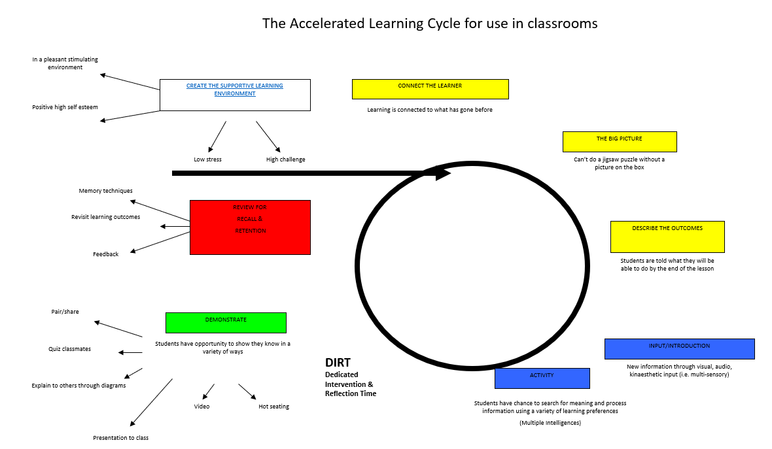

### **In Early Years**

Geography is taught in Reception as an integral part of the topic work through child-initiated and adult led activities. Activities and opportunities are presented to children following the Understanding of the World Strand of the Development Matters document and on leaving Reception the aim is that children will be able to ‘Talk about the features of their own immediate environment and how environments might vary from one another’.

### **In Key Stage 1**

Pupils will develop knowledge about the world, the United Kingdom and their locality. They will understand basic subject-specific vocabulary relating to human and physical geography and begin to use geographical skills, including first-hand observation, to enhance their locational awareness.

**In Key Stage 2**

Pupils will extend their knowledge and understanding beyond the local area to include the United Kingdom and Europe, North and South America. This will include the location and characteristics of a range of the world’s most significant human and physical features. They will develop their use of geographical knowledge, understanding and skills to enhance their locational and place knowledge.

**Preparation for Key stage 3**

The national curriculum for key stage 3 geography aims to ensure that all pupils:

* develop contextual knowledge of the location of globally significant places…
* understand the processes that give rise to key physical and human geographical features of the world…
* are competent in the geographical skills…

|  |
| --- |
| Quality first teaching in Geography has the following characteristics:   * Children being given a wide range of experiences and resources. * Children being encouraged to ask and answer questions, select and record information for evaluation and assessment. * Teachers in all classes exploring and planning appropriate opportunities for using ICT to enhance children’s learning experiences in Geography. * Being asked questions and asking to observe, record, express opinions, analyse evidence, draw conclusions, collect and record evidence. * By being taught to use correct vocabulary, develop fieldwork skills, use secondary sources, use globes and maps at a range of scales. * Undertaking fieldwork using a variety of skills, instruments and techniques. * Making using and interpreting maps and plans at a variety of scales. * building up a location framework of the size and position of places from the use of aerial photographs, plans, atlases and globes. * using ICT as an informative source as well as to handle, sort and present information. * investigating real people’s lives through meetings, case studies, videos, text and photographs. * undertaking studies of places and themes in both local and worldwide localities. * visiting a variety of places to enjoy first-hand experiences of what those places are like. * using secondary sources to learn about places they cannot visit. * discussing their own experiences of places or topical events e.g. holidays, sport, news. * collecting sorting and presenting data in diagrams and maps in order to recognise patterns and relationship within and between places. * Investigating physical and human processes through first-hand experiences or written resources, with increased independence. * undertaking local and worldwide studies focusing on the environmental, social and political issues that influence the character of the places. * exploring the significance of people’s beliefs, values and attitudes about the world.# * Investigating the need for sustainability within an environment or community. * investigating familiar places to which they belong. * considering the ways we are connected and linked to other places and people worldwide. * engaging in learning activities that promote positive values and attitudes towards people throughout the world. * By developing feelings for the qualities of both natural and human-influence landscapes through visits and visual materials. |

|  |
| --- |
| **Field Trips**  At Queenswood first-hand experience of geography outside the classroom is encouraged through the use of the school grounds, immediate school surroundings and field trips, where appropriate and we work closely with Shropshire Wildlife Trust who support us in our learning as a designated **nature friendly school.**   * Outdoor learning activities take place on a weekly basis for EYFS pupils. * Year 1 and 2 visit Ironbridge and Blists Hill museum. * Year 3 and 4 visit the Wrekin Hill and Wenlock Edge. * Year 5 and 6 undertake field work at Arthog outdoor centre, Wales. * Year 5 and 6 visit Llandudno , Ironbridge and the Coalport museum. |

**Recording and Assessment**

Pupils’ work is formatively assessed according to the progress they make towards the learning objectives set in each lesson.Pupils compolete a mind map at the end of each unit of work to assess their Knowledge they have remembered and they complete the key questions from the knowledge organisers.. Lesson objectives are based on the School’s medium-term plans and the School’s progression document.

We assess by observing and questioning the children, carrying out a scrutiny of work and discussions with children across the school for progression and to identify the areas for improvement.

Progress and achievement in Geography is reported to parents and carers each year in the annual report. This information is then passed onto their next teacher in the way of a summative assessment based on the expected key knowledge acquired and skills acquired in that key stage. Children are then assessed as working below/within/above that key stage. The Geography Co-ordinator will consider the progress of each group and offer support to develop the teaching and learning.

### **Reading and geography .**

Story telling is used as a key strategy to inform pupils about the different places and people in the world., celebrating diversity.

##### Inclusion

All children are given equal access to the programmes of study through differentiated support. Risk assessments are carried out before all fieldwork activities take place and TA support planned for anyone with a disability. Challenges and extension activities are provided for higher attainers and gifted and talented pupils.

**Role of the Geography Subject Leader**

* to develop the geography policy throughout the school
* to ensure all pupils in all year groups are reaching the expected standards in Georgraphy as set out in the national curriculum.
* to monitor progress in geography
* to keep up to date with development in geography education
* to offer support and advice to colleagues

Signed …Lee Ferriday…………….(Head)

Review Date:

Ovtober 2021

**MEDIUM TERM PLANS -The sequence of Geographical Knowledge in the Early Years**

|  |  |  |  |  |
| --- | --- | --- | --- | --- |
|  |  | **30-50m/40-60m)** | **(40-60m/ELG)** | **(ELG/Exceeding)** |
| New ELG *(from Sept 2021):* Describe their immediate environment using knowledge from observation, discussion, stories, non-fiction texts and maps | People Cultures and Communities | Explore and talk about and ask questions about the environment they live in.  Talk about the features of their environment – i.e. plants and areas of the environment – use small world people and construction to be able to create their own environment/map  Look at photographs and talk about how their environment changes over time – for example new houses being built.  Children need to be able to care for their environment. | Children need to be able to use their imagination to create their own environments and then discuss how these environments change as they change/adapt them.  Spot patterns within their environments – i.e. brickwork, simple maps  Recreate maps throughout block play, range of construction materials.  Notice different buildings (including those of religious importance) in their local area and how they vary. | Children know about similarities and differences in relation to places, objects, materials and living things.  Talk about and compare features of their own immediate environment and how different environments might vary from one another.  Make observations about why some changes to the environment happen, for example pollution and how we can help the world we live in.  Describe environments using non-fiction books and maps.  Compare two different areas using maps (Simple Ordinance Survey maps or ariel view maps) |
| *Key vocabulary* |  | *Pupils should explain, summarise and identify Town, road, path, houses, buildings, gardens, playgrounds, parks . Near and far* | *Maps, buildings, area, places, changes, differences, flats, churches, synagogues, village* | *Observational, select, adapt, change, differences, map, symbol, signs, ariel view* |

**The sequence of Knowledge to be taught in Key Stage 1**

|  |  |  |  |
| --- | --- | --- | --- |
| **Category of knowledge** | **NC statements** | **KS1**  **Cycle A – learning connected through the topics of Our School and Our World** | **KS1**  **Cycle B- learning connected through the topic of**  **The UK countries and weather and Telford compared to Llandudno** |
| Locational and place knowledge  Geographical skills and fieldwork to support locational knowledge | name and locate the world’s seven continents and five oceans    name, locate and identify characteristics of the four countries and capital cities of the United Kingdom and its surrounding seas  Use maps, atlases, globes, digital mapping to locate countries and describe features studied | * Know the names of the four countries that make up the UK and name the bodies of water that surround the UK * Recognise the seven continents of the world. * Identify some of the human and physical characteristics of the four countries of the UK.   ***pupils should explain, summarise and demonstrate their understanding of :***  *England, Ireland, Scotland, Wales,*  *North Sea, Irish Sea, English Channel and Atlantic Ocean.*  *Europe, Africa, Antarctica, North America, South America, Asia and Australasia (Oceania).*  *Know features of hot and cold places in the world. Understand location in relation to the Equator, South and North Pole.* | * Know the names of and locate the seven continents of the world * Know the names of and locate the five oceans of the world * Know the name of and locate the four capital cities of England, Wales, Scotland and Northern Ireland * Describe some of the human and physical characteristics of the four countries of the UK.   ***, pupils should explain, summarise and demonstrate their understanding of*** *Physical – Beach, cliff, forest,hill, mountain, sea, ocean, river, soil, valley ,vegetation, season and weather.*  *Human- city, town, village, factory, farm, house, officed, port , harbour ansd shop. ,Europe, Africa, Antarctica, North America, South America, Asia and Australasia (Oceania).*  *Atlantic, Pacific, Indian, Southern and Arctic ocean.*  *London, Cardiff, Edinburgh and Belfast.*  *Know the main differences between a home town and that of a small place in a non-European country (maybe linked to topic)* |

|  |  |  |  |
| --- | --- | --- | --- |
| **Category of knowledge** |  | **Lower Ks2**  Cycle A -**– learning connected through the topics Rivers and water and study of Shropshire also Local area map work** | **Lower KS2**  **Cycle B learning connected through the topics of Study of Italy** |
| Geographical skills and fieldwork to support locational knowledge | Use maps, atlases, globes, digital mapping to locate countries and describe features studied  • use the eight points of a compass, four and six-figure grid references, symbols and key (including the use of Ordnance Survey maps) to build their knowledge of the United Kingdom and the wider world  • use fieldwork to observe, measure and record the human and physical features in the local area (including sketch maps, plans and graphs) | Using a range of maps and atlases; locate a variety of countries and capitals, identify lines of longitude and latitude  • Using an Ordnance Survey map 1:50,000;  • Explain a range of OS symbols and key  • Four figure grid references  • Begin to demonstrate an understanding of the eight points of a compass  • Compare and contrast human and physical features using terrestrial, aerial and satellite photographs  • observe and measure (e.g. rainfall, temperature)  • Demonstrate an understanding of recording, presenting and interpreting data (bar charts, tables, line graphs)  ***Pupils should explain, summarise and demonstrate their understanding of Weather maps, climate maps, physical, human, OS Maps*** | Using a range of maps and atlases (digital online mapping and data retrieval (google earth): locate the equator, the Tropics of Cancer and Capricorn  • Know how to plan a journey within the UK, using a road map  • Using an Ordnance Survey map 1:50,000;  • Explain and use an increased range of OS symbols and key  • Four figure grid references  • Spot heights  • Estimate area  • Demonstrate an understanding of the eight points of a compass  • Estimate straight line distances using a scale line  • Compare and contrast human and physical features using terrestrial, aerial and satellite photographs  • observe and measure (e.g. rainfall, temperature)  • Demonstrate an understanding of recording, presenting and interpreting data (bar charts, tables, line graphs, flow line)  ***pupils should explain, summarise and demonstrate their understanding of Weather maps, climate maps, thematic maps, spot heights, north-west etc, scale line, digital online mapping and data retrieval (google earth), OS maps , Biomes and vegetation*** |

|  |  |  |  |
| --- | --- | --- | --- |
|  |  | Upper KS2 Cycle A -**– learning connected through the topics of Global mapping and UK Mapping** | Upper KS2 Cycle B **learning connected through the topics of North America and Volcanoes and earthquakes** |
| Knowledge of Geographical skills and fieldwork to support locational knowledge | Use maps, atlases, globes, digital mapping to locate countries and describe features studied  • use the eight points of a compass, four and six-figure grid references, symbols and key (including the use of Ordnance Survey maps) to build their knowledge of the United Kingdom and the wider world  • use fieldwork to observe, measure and record the human and physical features in the local area (including sketch maps, plans and graphs) | Using a range of maps, atlases, digital online mapping and data retrieval (e.g. google earth) locate countries and capitals from around the world including the northern and southern hemisphere.  • Using an Ordnance Survey map 1:25,000;  • Classify a range of OS symbols and key  • Six figure grid references  • Estimate height using contour lines  • Understand the eight points of a compass  • Calculate straight line distance using a scale line  • Use terrestrial, aerial and satellite photographs to identify geographical features  • observe and measure (e.g. rainfall, temperature)  • Demonstrate an understanding of recording, presenting, interpreting and evaluating data (pie charts, climate graphs)  *Pupils should* ***justify, apply and evaluate*** *to show their understanding Weather maps, climate maps, thematic maps, spot heights, pie charts, climate graphs, north-west etc, scale line, digital online mapping and data retrieval (g*  *oogle earth), OS maps* | Using a range of maps, atlases, digital online mapping and data retrieval (e.g. google earth) to locate countries and places of interest (e.g. journey of a river, fault lines, ring of fire, forest cover)  • Using an Ordnance Survey map 1:25,000;  • Classify a range of OS symbols and key  • Six figure grid references  -usiing a line on an os map of California describe the journey along the line. Include contours. Symbols.  • Estimate height and slope using contour lines .  • Apply the eight points of a compass  • Calculate straight line and actual distance using a scale line  • Make informed statements using terrestrial, aerial and satellite photographs (deforestation, decline of Great Barrier Reef, Ice caps melting)  • observe and measure (e.g. rainfall, temperature)  • Demonstrate an understanding of recording, presenting, interpreting and evaluating data (scatter graphs, pie charts, climate graphs)    ***Pupils should justify, apply and evaluate to show their understanding of*** *Weather maps, climate maps, thematic maps, spot heights, pie charts, climate graphs, north-west etc, scale line, scatter graphs, digital online mapping and data retrieval (google earth), OS maps* |

